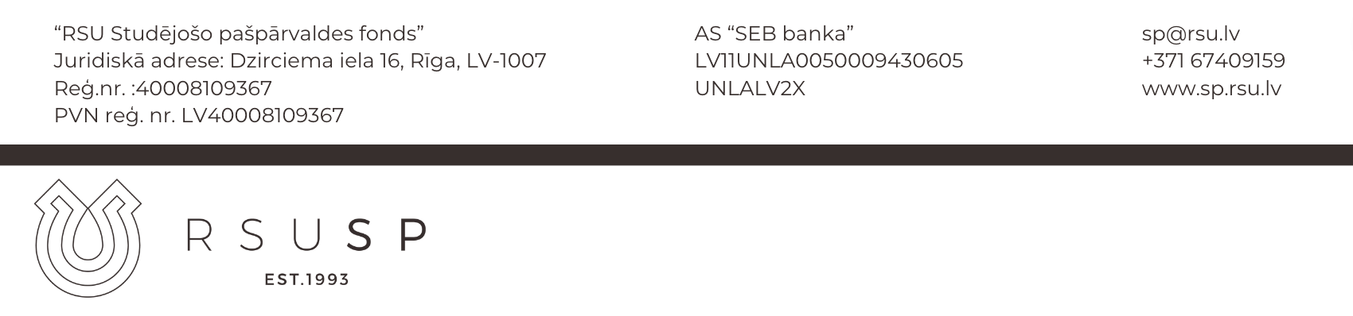
ORDER
RSU SP iekšējās finanšu kārtības
Pielikums nr.2
APSTIPRINĀTS
RSU SP Padomes sēdē nr. 2-STP-11/9/2022

Riga

About requesting and receiving money

I certify for RSU SU for ensuring the operation of the project __________________________ I have spent __________ EUR, purchasing the following goods and services:
Nr. | Receipt Nr.: | Product or service: |  |  | Product/ service reason of purchase: |  |  | Sum  (EUR):
To be completed by the Financial Administrator |  |  | Tāme: |  |  | Pozīcija:

Make a refund to ______________________________________________
^{Name of the applicant}
to this bank account: __________________________________________
The applicant's bank account number to which the refund is to be made
SWIFT:

. ________________________/_______________________________
^{Signature} ^{Deciphering of the signature}

Application for refund received (completed by the Financial Administrator):
_________________________/________________________
^{Signature} ^{Deciphering of the signature}

Money transfer confirmed (filled by the Chairman of the Board of RSU SU):

_________________________/________________________
^{Signature} ^{Deciphering of the signature}

